PYTHON SCRIPT

TEAM LEAD : DEEPTI.S

TEAM MEMBER : DHARANIDHARAN S V

KIRUBAKARAN V

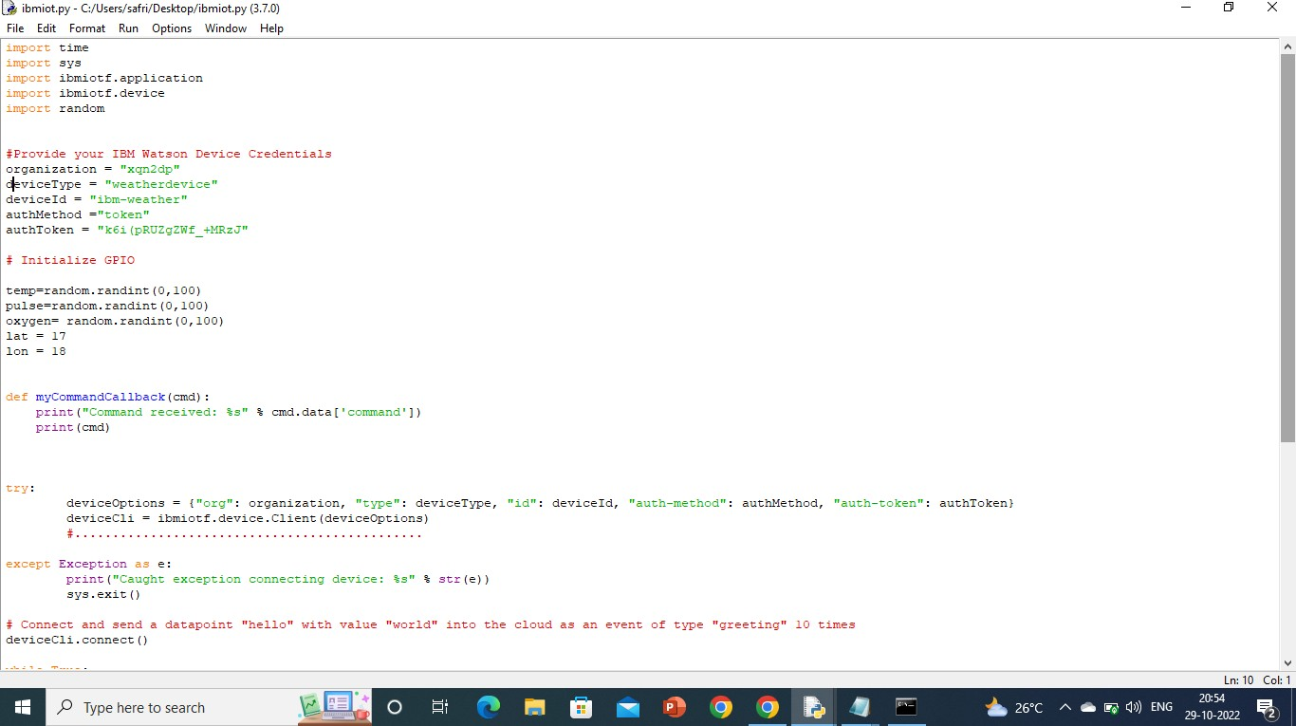 LATCHYA SHREE G

